13.88: The torque on the rod about the pivot (with angles positive in the direction indicated in the figure) is 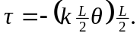 Setting this equal to the rate of change of angular momentum, 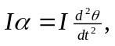
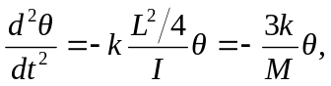

where the moment of inertia for a slender rod about its center,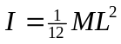 has been used. It follows that 